EXPERIMENT-6

NAME-Jayesh M

ROLL NO-11

PRN NO-1032220100

Using Excel – INDEX, MATCH

**Assignment A:**

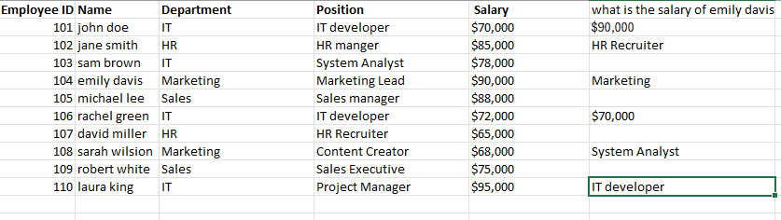

Questions:

1. What is the salary of “Emily Davis”?

**=INDEX(E2:E11, MATCH("Emily Davis", B2:B11, 0))**

2. What is the position of the employee with Employee ID 107?

**=INDEX(D2:D11, MATCH("david miller",B2:B11, 0))**

3. Which department does “Sarah Wilson” belong to?

**=INDEX(C2:C11, MATCH("Sarah wilsion", B2:B11, 0))**

4. What is the salary of “John Doe”?

**=INDEX(E2:E11, MATCH("john doe", B2:B11, 0))**

5. Which department does the employee with Employee ID 103 belong to?

**=INDEX(D2:D11, MATCH("sam brown",B2:B11, 0))**

6. What is the position of “Rachel Green”?

**=INDEX(D2:D11, MATCH("rachel green", B2:B11, 0))**

**Assignment B:**

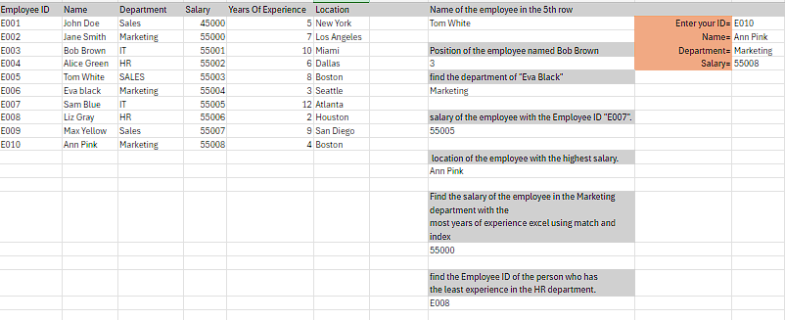

1. Basic INDEX Function

Retrieve the name of the employee in the 5th row of the dataset.

**=INDEX(B2:B11,5)**

**2. Basic MATCH Function**

**Find the position of the employee named “Bob Brown” in the dataset.**

**=MATCH("Bob Brown",B2:B11,0)**

**3. Combining INDEX and MATCH**

**Use the INDEX and MATCH functions together to find the department of “Eva Black”.**

**=INDEX(C2:C11,MATCH("Eva Black",B2:B11,0))**

**Find the salary of the employee with the Employee ID “E007”.**

**=INDEX(D2:D11,MATCH("E007",A2:A11,0))**

**Retrieve the location of the employee with the highest salary.**

=INDEX(B2:B11,MATCH(MAX(D2:D11),D2:D11,0))

**4. Advanced INDEX and MATCH**

**Find the salary of the employee in the Marketing department with the**

**most years of experience.**

=INDEX(D2:D11, MATCH(MAX(IF(C2:C11="Marketing", E2:E11)), IF(C2:C11="Marketing", E2:E11), 0))

**Use INDEX and MATCH to find the Employee ID of the person who has**

**the least experience in the HR department.**

=INDEX(A2:A11, MATCH(MIN(IF(C2:C11="HR", E2:E11)), IF(C2:C11="HR", E2:E11), 0))

**5. Dynamic Lookup**

**Create a dynamic lookup where you can enter an Employee ID in a**

**separate cell, and it returns the corresponding Name, Department, and**

**Location using INDEX and MATCH.**

=INDEX(B2:B11, MATCH(J2, A2:A11, 0))

=INDEX(C2:C11, MATCH(J2, A2:A11, 0))

=INDEX(D2:D11, MATCH(J2, A2:A11, 0))